Healthy Galway City Co-ordinator
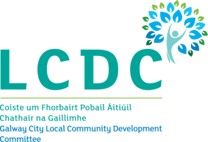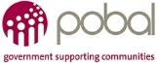
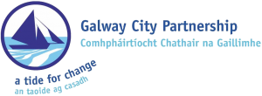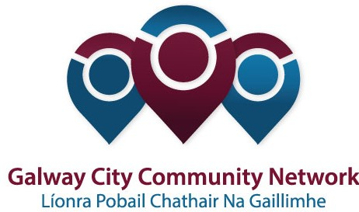

Healthy Galway City is looking for an energetic, dynamic person with knowledge in the area of health and wellbeing to co-ordinate its Healthy Galway City project until March 2018. The person will have a community work qualification and will have worked at a management/co-ordination level for at least three years.

Background
Healthy Ireland, A Framework for Improved Health and Wellbeing 2013-2025 is the national framework for action to improve the health and wellbeing of Ireland over the coming generation.
Healthy Ireland has created a fund that was open to Local Community Development Committees. The primary aim of the fund is to support innovative, cross-sectoral, evidence-based projects and initiatives that support the implementation of key national policies in areas such as obesity, smoking, alcohol, physical activity and sexual health.
The objectives of the initial stages of the Fund are:
- To raise awareness of, and support for, Healthy Ireland through the funding of community-based and national health promotion activities.
- To facilitate and resource cross-sectoral and partnership networks that promote health and well-being.
- To resource the development of locally-led, cross-sectoral strategies promoting health and wellbeing.
- To add value to existing health promotion initiatives through the provision of Healthy Ireland resources.
- To support the health and wellbeing of the most disadvantaged groups and areas and those experiencing significant health inequalities through long-term planning.
The Local Community Development Committee and Galway City Community Network, the Public Participation Network in Galway City, facilitated the development of a strategic approach to the Healthy Ireland application. The LCDC was successful in its application to the Healthy Ireland Fund. Healthy Galway City is based on the concept promoted by Healthy Ireland that aims to promote a comprehensive and whole system approach to planning for health and wellbeing. Healthy Galway City now wishes to recruit a suitably qualified person to co-ordinate the project and to deliver a number of the actions.

Healthy Galway Co-ordinator

The Position
The Healthy Galway Coordinator will co-ordinate the implementation of the initial Healthy Galway Strategy to March 2018. The actions in the strategy reflect goals and priorities from local and national strategies that have a role in improving the health and wellbeing of people living in Galway City. These key documents include, but are not limited to
- Healthy Ireland – The National Framework for Health and Wellbeing
- National Physical Activity Plan
- Healthy Weight for Ireland Obesity Plan
- Tobacco Free Ireland
- National Sexual Health Plan
- Galway City Local Economic and Community Plan (LECP)

Duration
The position is full-time and the initial contract will be until March 2018. Subject to funding and agreement, the contract may be extended.

The Employer
Galway City Partnership will be the host for the project and will be the employer of the Healthy Galway Co-ordinator.

Key Duties and Responsibilities
The key responsibilities of the Healthy Galway Co-ordinator are to;
- Co-ordinate, support and monitor the implementation of the Healthy Galway strategy;
- Implement key actions identified from the Healthy Galway strategy;
- Support work of and provide regular progress reports to the Healthy Galway Subgroup of the Galway City LCDC;
- Establish and support a Healthy Galway Forum that will include all Lead and Partner organisations;
- Facilitate and support Lead Organisations (LOs) in the planning, development and implementation of actions set out in the initial Healthy Galway Strategy;
- Establish a recording process for LOs in relation to all activities and produce composite an end of project report;
- Provide networking events and shared learning opportunities for all project stakeholders;
- Engage with the Healthy Cities Network at local and national level;
- Facilitate the provision of training in equality and human rights to project tutors and facilitators;
- Develop and implement a communications strategy including the production of a project e-newsletter highlighting activities, strategies and learning from the project;
- Generate and disseminate accessible information and analysis for all stakeholders;
- Represent the project in relevant fora;
- Liaise with coordinators at regional level to share experience and learning;
- Working closely with the appointed consultant, oversee the process for the development of the Healthy Galway City Strategic Plan 2018-2021;

Person Specification
The Healthy Galway City Co-ordinator will have a third level qualification in community work/community development or equivalent (relevance to be demonstrated) and at least 3 years’ experience working in a leadership role in the community, local development or health promotion sectors. The Healthy Galway City Co-ordinator will:
- Have an understanding of health from a social determinants perspective and the particular issues affecting communities experiencing health inequalities, poverty, social exclusion and inequality;
- A strong analysis of the structural causes of health inequalities;
- Core relevant national and local health policies and strategies;
- Local government, community development and local development programmes, policies and structures.
The Healthy Galway City Co-ordinator will have proven skills in the areas of;
- Communication (strong interpersonal skills);
- Leadership
- Building alliances and cross sectoral working;
- Strategic planning and strategy development
- Participatory planning
- Group work, training and facilitation;
- Presentation and report writing;
- Information technology (particularly as an information and communication tool);
- Representation;
- Project management.
The Healthy Galway City Co-ordinator will possess the following qualities;
- A commitment to the values of equality, human rights and social inclusion
- Professionalism
- Integrity
Access to a car will be a necessity.

