Healthy Galway City Needs Analysis and Strategic Plan
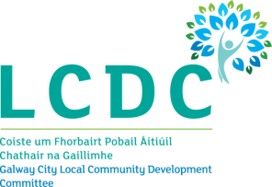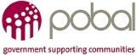
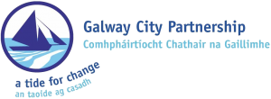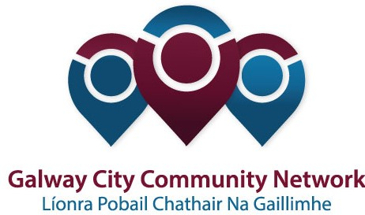

Background
Healthy Ireland, A Framework for Improved Health and Wellbeing 2018-2021 is the national framework for action to improve the health and wellbeing of Ireland over the coming generation.
Healthy Ireland has created a fund that was open to Local Community Development Committees. The primary aim of the fund is to support innovative, cross-sectoral, evidence-based projects and initiatives that support the implementation of key national policies in areas such as obesity, smoking, alcohol, physical activity and sexual health.
The objectives of the initial stages of the Fund are:
- To raise awareness of, and support for, Healthy Ireland through the funding of community-based and national health promotion activities.
- To facilitate and resource cross-sectoral and partnership networks that promote health and well-being.
- To resource the development of locally-led, cross-sectoral strategies promoting health and wellbeing.
- To add value to existing health promotion initiatives through the provision of Healthy Ireland resources.
- To support the health and wellbeing of the most disadvantaged groups and areas and those experiencing significant health inequalities through long-term planning.
The Local Community Development Committee and Galway City Community Network, the Public Participation Network in Galway City, facilitated the development of a strategic approach to the Healthy Ireland application. The LCDC was successful in its application to the Healthy Ireland Fund. Healthy Galway City is based on the concept promoted by Healthy Ireland that aims to promote a comprehensive and whole system approach to planning for health and wellbeing.

Healthy Galway City Strategic Plan
On behalf of Healthy Galway City, Galway City Partnership is seeking to engage a suitably qualified consultant to undertake a needs analysis and develop a strategic plan for Galway Healthy City. The process will build on the initial Healthy Galway City strategy to develop a longer-term strategy to ensure Galway is a city where everyone can enjoy physical and mental health and wellbeing to their full potential.
The process of developing the strategy will be based on a cross-sectoral, interagency, partnership approach that will encourage organisations and agencies to work in partnership to address health inequalities in Galway City. The process will be collaborative and will include a significant, robust consultation process to identify local priority needs and develop strategies to address them under the framework of Healthy Ireland and its sub-strategies. The successful applicant will be required to demonstrate a range of methodologies and consultation processes that will deliver on this objective.

Aim
The aim of the project is to develop a robust strategic plan for Healthy Galway City that is underpinned by a robust needs analysis. To that end, the consultant will:

Carry out a policy analysis that will provide the framework for the strategic plan;

Carry out a significant collaborative and robust needs analysis of health and wellbeing in Galway City, with particular reference to marginalised communities. This will include secondary and primary methods of data gathering and analysis;
- Map existing health and wellbeing initiatives and identify gaps;
- Design and deliver a series of strategic planning workshops;
- Produce a strategic plan that is underpinned by a report of the needs analysis;
- Produce an implementation plan with costed actions and deliverables.
The consultant will be expected to:
- Report to the Steering Committee on a regular basis;
- Provide a draft report of the needs analysis and strategic plan for comment;
- Incorporate the comments into a final report and plan.

Anticipated methodology
It is anticipated that the consultant will use a range of methodologies including:
- Secondary research;
- Policy analysis;
- Surveys, including on-line surveys;
- Interviews;
- Focus Groups;
- Strategic Planning workshops.
The consultant will be expected to be mindful of the need to ensure buy-in from a range of actors and stakeholders and to construct a process that will deliver this.

Person Specification
The successful consultant will be required to demonstrate or provide evidence of the following:
- Excellent social research skills including the ability to design, analyse and present primary and secondary qualitative and quantitative data and information;
- Excellent facilitation skills;
- An understanding and appreciation of the issues and needs confronting communities and their health and wellbeing needs;
- Knowledge of government policy as it relates to health and wellbeing;
- Excellent presentation skills.
- Good interpersonal & organisational skills.

Applications
Please set out clearly:
- A detailed project plan to ensure the objectives of the project are achieved in a way that ensures ownership and buy-in by stakeholders;
- Details of previous, similar work undertaken and reference sites, including a CV of the individual/s making the proposal;
- Costing inclusive of all incidental expenses (including travel and subsistence costs) and VAT if applicable. Please indicate the cost per day, the total number of days, and the number of days for each stage.
- The time frame for completion of the project as a whole.

Budget
A budget of no more than €8,000, including per diem costs, travel and subsistence, VAT and all incidental costs is available. Payment will be made in instalments, subject to invoices, based on a schedule to be agreed with the successful bidder(s).
Timescale
The timescale for the work will commence on award of the contract and completed and finished by March 30th 2018. The following interim outputs are expected:
- the provision of an interim report by February 23rd 2018
- final report ready for publishing by March 30th 2018

Assessment of Tender
Each tender received will be assessed on the basis of the following award criteria
Award Criteria | Marks Available
Demonstrated knowledge and understanding of the brief | 40
Track record in relevant work | 20
Experience in using methodologies as outlined in the project description | 20
Availability to carry out the project within the stated timeframe | 10
Price | 10
Total Marks | 100

