Towards a Tobacco Free Galway City Project Worker
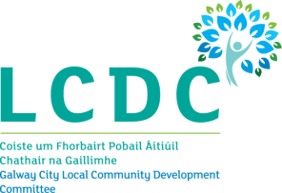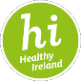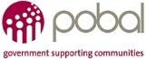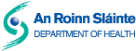
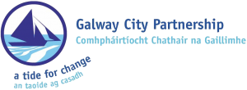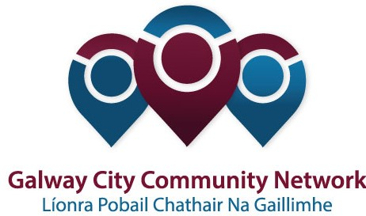

Healthy Galway City is looking for an energetic, dynamic person with knowledge in the area of health and wellbeing to implement the Towards a Tobacco Free Galway initiative until March 2018. The person will have a community work qualification and at least three years’ experience of working in community work.

Background
Healthy Ireland, A Framework for Improved Health and Wellbeing 2013-2025 is the national framework for action to improve the health and wellbeing of Ireland over the coming generation.
Healthy Ireland has created a fund that was open to Local Community Development Committees. The primary aim of the fund is to support innovative, cross-sectoral, evidence-based projects and initiatives that support the implementation of key national policies in areas such as obesity, smoking, alcohol, physical activity and sexual health.
The objectives of the initial stages of the Fund are:
- To raise awareness of, and support for, Healthy Ireland through the funding of community-based and national health promotion activities.
- To facilitate and resource cross-sectoral and partnership networks that promote health and well-being.
- To resource the development of locally-led, cross-sectoral strategies promoting health and wellbeing.
- To add value to existing health promotion initiatives through the provision of Healthy Ireland resources.
- To support the health and wellbeing of the most disadvantaged groups and areas and those experiencing significant health inequalities through long-term planning.
The Local Community Development Committee and Galway City Community Network, the Public Participation Network in Galway City, facilitated the development of a strategic approach to the Healthy Ireland application. The LCDC was successful in its application to the Healthy Ireland Fund. Healthy Galway City is based on the concept promoted by Healthy Ireland that aims to promote a comprehensive and whole system approach to planning for health and wellbeing. Healthy Galway City now wishes to recruit a suitably qualified person to implement the Towards a Tobacco Free Galway initiative.

Towards a Tobacco Free Galway City Project Worker

The Position
The Towards a Tobacco Free Galway City Project Worker will implement the Towards a Tobacco Free initiative, which is part of the Healthy Galway City strategy.

Duration
This part-time contract will be until March 2018.

The Employer
Galway City Partnership will host project and will be the employer of the Towards a Tobacco Free Galway City Project Worker. The Project Worker will report to the Galway Healthy City Co-ordinator.

Key Duties and Responsibilities
The key responsibilities of the Towards a Tobacco Free Galway City Project Worker are to;

Develop information materials and welcome pack to support Smoke Free Homes Project in line with best practice

Link with other Smoke Free Homes Projects, HSE and other organisations

Collaborate with local stakeholders in developing the project

Develop a web page for the existing website to promote the project

Raise awareness of the project through the development and implementation of a communications and media strategy and through outreach work with households

Undertake weekly follow up with participants who register for the project

Collate and monitor data in relation to the project;
- Co-ordinate the implementation of the X-Hale and the NRT (Nicotine replacement Therapy) elements of the initiative;
- Provide updates and progress reports to the Healthy Galway City Co-ordinator.

Person Specification
The Towards a Tobacco Free Galway City Project Worker will have a third level qualification in community work/community development or equivalent (relevance to be demonstrated) and at least 3 years’ experience working the community, local development or health promotion sectors. The Project Worker will:
- Have an understanding of health from a social determinants perspective and the particular issues affecting communities experiencing health inequalities, poverty, social exclusion and inequality;
- A strong analysis of the structural causes of health inequalities;
- Core relevant national and local health policies and strategies;
- Local government, community development and local development programmes, policies and structures.
The Towards a Tobacco Free Galway City Project Worker will have proven skills in the areas of;
- Communication (strong interpersonal skills);
- Leadership
- Building alliances and cross sectoral working;
- Strategic planning and strategy development
- Participatory planning
- Group work, training and facilitation;
- Presentation and report writing;
- Information technology (particularly as an information and communication tool);
- Representation;
- Project management.
The Towards a Tobacco Free Galway City Project Worker will possess the following qualities;
- A commitment to the values of equality, human rights and social inclusion
- Professionalism
- Integrity

